Exception Handling in Power Automate Flow

**Step 1:** Add 3 Scope controls in your flow. Scope - Encapsulate a block of actions and inherit the last terminal status (Succeeded, Failed, Cancelled) of actions inside.

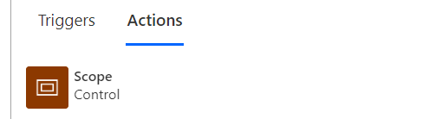

**Step 2:** Rename these scope controls to Try, Catch and Finally.

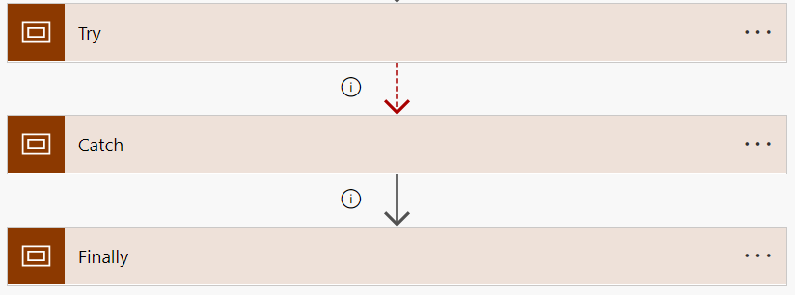

**Step 3:** Add all your logic actions/ steps in Try scope.

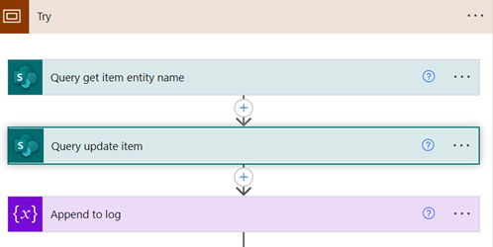

**Step 4:** Change run after setting of Catch scope to run only if Try scope has failed, is skipped or has timed out. Uncheck is successful.

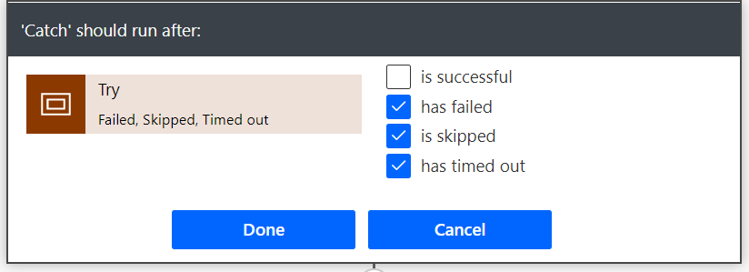

**Step 5:** In Catch block add logic to set variables for logging purpose and status

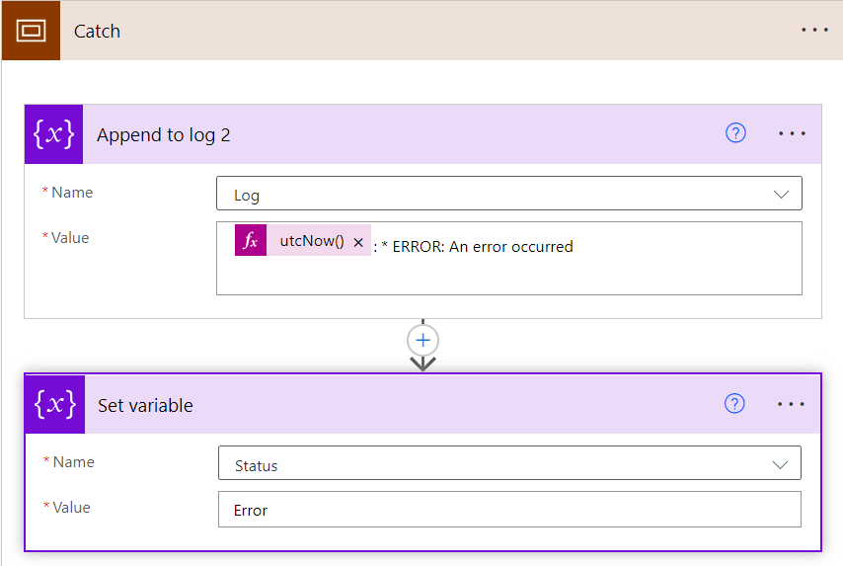

**Step 6:** In Finally block, you can either log the error message in any SharePoint list or send email notification to some group or individual with error details or both.

